Level 1 BBSM 5.2 Support Procedures

Table of Contents
BBSM Overview 3
V5.2 Verses V5.1 3
Connecting to the BBSM dashboard 4
WEBconfig 5
SMTP Redirection 5
IP Addresses 6
Client Deactivation 7
Permanently Deactivate a Client 9
Reactivate a Client 10
User Has a Private Address and Wants a Public IP Address 11
Access Codes 11
Error Messages 11
Searching Error RME 19 + 7 11
Portal Page is Looping 11
Network Temporarily Unavailable 11

BBSM Overview

The Cisco Building Broadband Services Manager (BBSM) is a combination hardware and software platform performing as a subscriber gateway for public access networks. The hardware consists of a 1U high server with a serial port, floppy and CD-ROM drives in the front, mouse port, keyboard port, monitor port, 2 USB ports, serial port (used for PMS billing) and two integrated Intel Network interface connectors (NIC’s) in the back (see below). The processor is a 1 GHz Pentium III standard with 256 MB RAM upgradeable to 1GB. The software consists of Windows 2000 Server, configured stand-alone for our sites along with Cisco’s BBSM software. Additionally the server comes with Microsoft’s ISA Server and is configured to run as a DNS server.

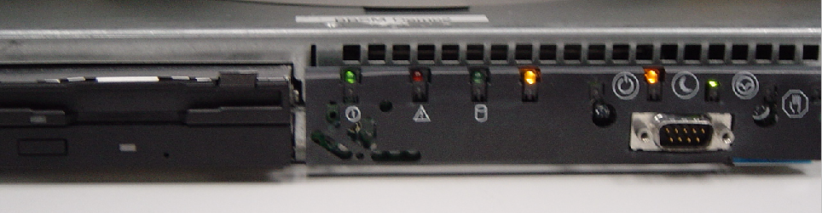
Figure 1 - BBSM Front View

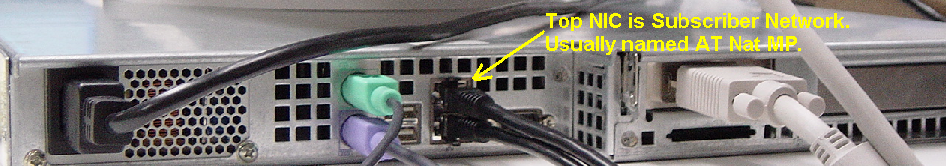
Figure 2 - BBSM Back View

V5.2 Verses V5.1

Version 5.2 of the BBSM, it is possible to configure multiple logical networks (Multinet) on the subscriber side so that both private and public addresses can be assigned to guests. This is one of the major differences between V5.2 and V5.1. With V5.1 of the BBSM the secondary IP address is not recognized by the BBSM. This means that guests will not be able to receive public IP addresses via DHCP if the subscriber side has been configured with a private IP address range. Since we are in general, not reconfiguring guest PC’s, it will not be possible to give a guest a Public address for VPN access if the Hotel has a V5.1 BBSM and the subscriber side is only configured for private addresses.

Connecting to the BBSM dashboard

To connect to the BBSM, you need to use a web browser. The URL is http://<IP address of BBSM server>:9488/www. In our example, you would use http://12.159.210.2:9488/www

After connecting to the page, you have to login with a username and password. After logging in, you should receive the following screen.

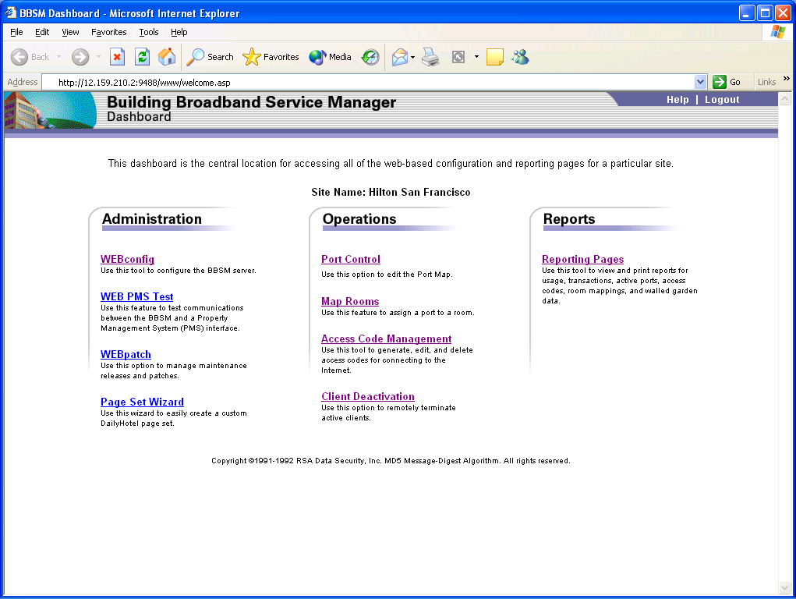

This screen is known as the BBSM Dashboard. From here you will be able to perform all actions on the BBSM server software.

WEBconfig

This section is where all the configurations take place. This should all be done by the installer at the time of installation. However, you can find useful information here. WARNING: When you are in the WEBconfig screen, new users will not be able to connect. Exit out as soon as possible.

SMTP Redirection

SMTP redirection is when the BBSM redirects all SMTP traffic to a predetermined SMTP server. No matter what the user has configured for the SMTP settings, it will be sent to the predetermined server. To see if the property has SMTP redirection setup, Select WEBconfig from the Dashboard, you should receive a screen similar to below:

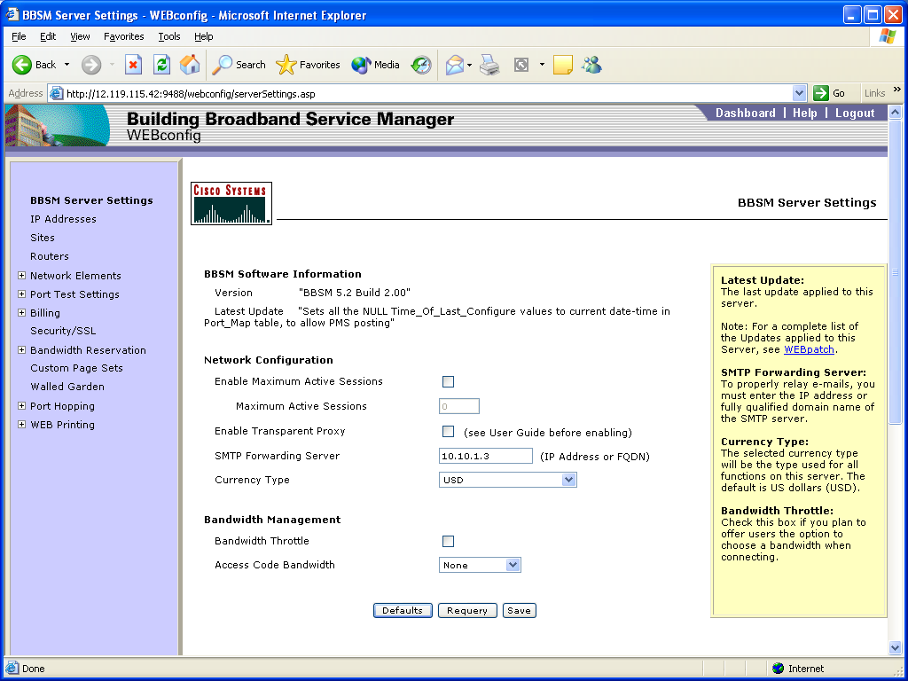

If the SMTP Forwarding Server field is filled out, then this is the server that will forward ALL SMTP mail.

IP Addresses

Select WEBconfig, IP addresses. You should receive a screen similar to below:

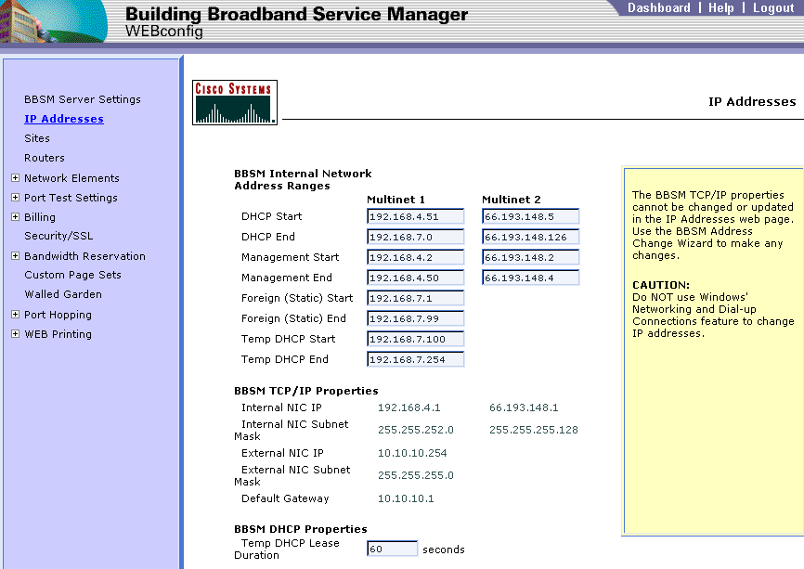

BBSMs have three pools. Temp, Multinet 1, Multinet2. The guest will first get a Temp IP address. Once they have signed up for a private IP address they will get an address from multinet 1. If they signup for a public IP address they will get an IP address from multinet 2.

Client Deactivation

Use this option to remotely terminate active clients.

From the BBSM Dashboard click on Client Deactivation and you will receive this screen.

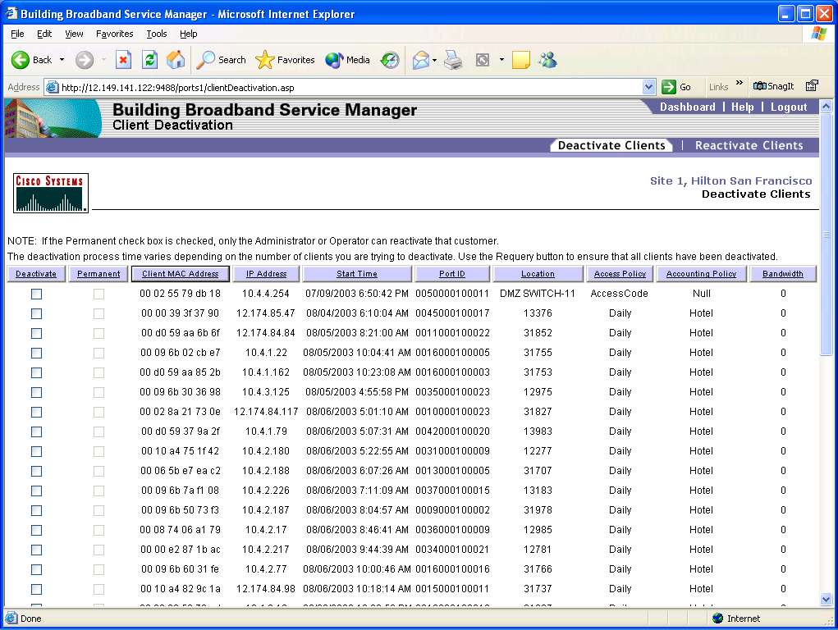

Deactivate a Client

You can deactivate a client’s session only. This feature does not allow you to delete a client’s account.

From the BBSM dashboard select Client Deactivation. This lists all clients that are currently connected. Find the user’s IP address or MAC address in the list. Check the box next to the client you want to deactivate. At the bottom of the screen select deactivate clients.

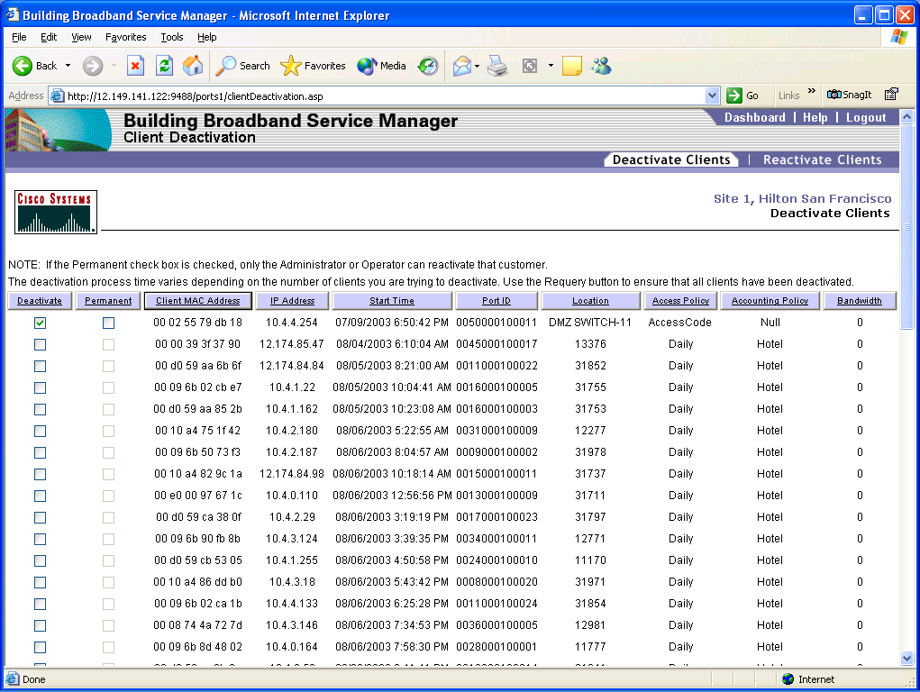

Permanently Deactivate a Client

This feature will allow you to block access to the BBSM for a user’s MAC address permanently. Use this feature only if instructed by the property to block the user!

From the BBSM dashboard select Client Deactivation. This lists all clients that are currently connected. Find the user’s IP address or MAC address in the list. Check the box next to the client you want to deactivate. Also select Permanent check box. At the bottom of the screen select deactivate clients.

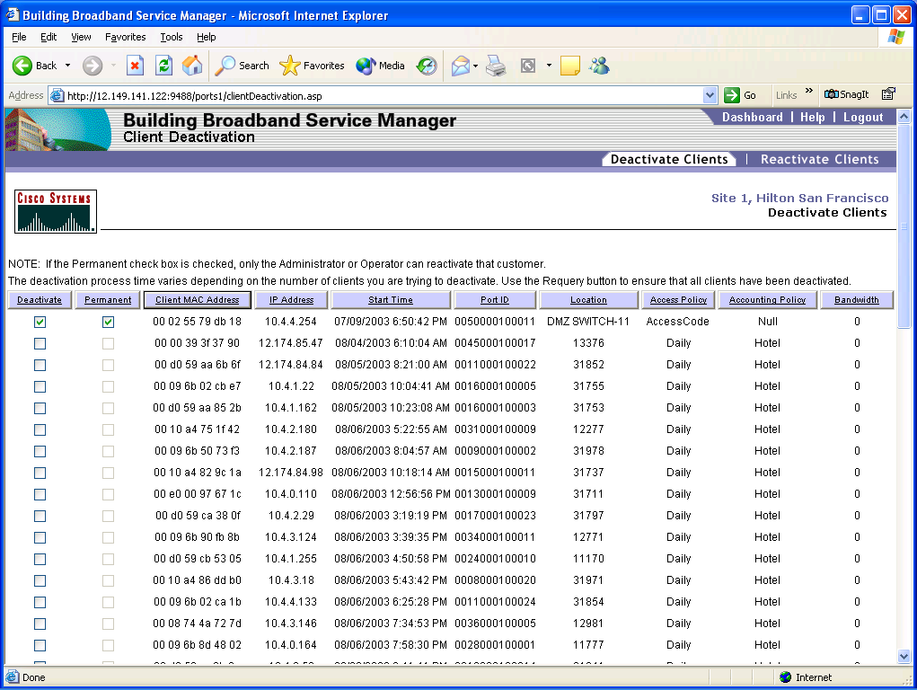

Reactivate a Client

This feature allows you to reactivate a permanently deactivated client.

From the BBSM dashboard select Client Deactivation. From the menu at the top of the screen, select reactivate clients. Find the user’s IP address or MAC address in the list. Check the box next to the client you want to reactivate. At the bottom of the screen select reactivate clients.

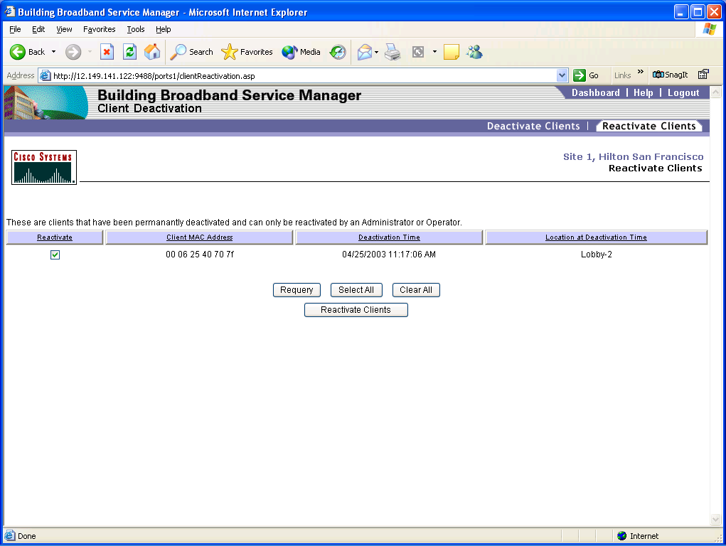

User Has a Private Address and Wants a Public IP Address

If the user has a purchased a private address and now needs a public IP address, then follow the procedure above to deactivate the client. After the user’s session has been deactivated, have the user release and renew their IP address. The user should now get a temporary address. When the user opens their browser, they will get the welcome back screen and have the option for Public IP address.

This procedure can be property specific, it depends on the portal page screens that the property has.

Access Codes

Access codes are managed by the front desk at the hotel. For issues with access codes you can escalate to 2nd level but for the most part the guest will need to talk to the front desk to get a new access code.

Error Messages

If a user receives an error message from the BBSM server, the browser window will contain a globe and should have an error code at the bottom of the screen.

Searching Error RME 19 + 7

This error means that the user’s MAC address was not found on any switches in the network. This call should be passed to 2nd Level.

Portal Page is Looping

This is when the user gets the billing screen, selects the plan or enters the access code, selects connect and it goes back to the billing screen.

What this means is that the BBSM server did not authenticate the user. The access code was entered incorrectly or the room is not mapped. Send to 2nd Level if you cannot resolve the issue.

Network Temporarily Unavailable

This error is when someone is in the WEBconfig screen of the Dashboard. New users will not be able to connect since the BBSM is under configuration. When you exit WEBconfig, the users will be able to connect and signup.

